|  |
| --- |
| **ATUL ANAND**  +91-7903631537  atul.anand@capgemini.com |

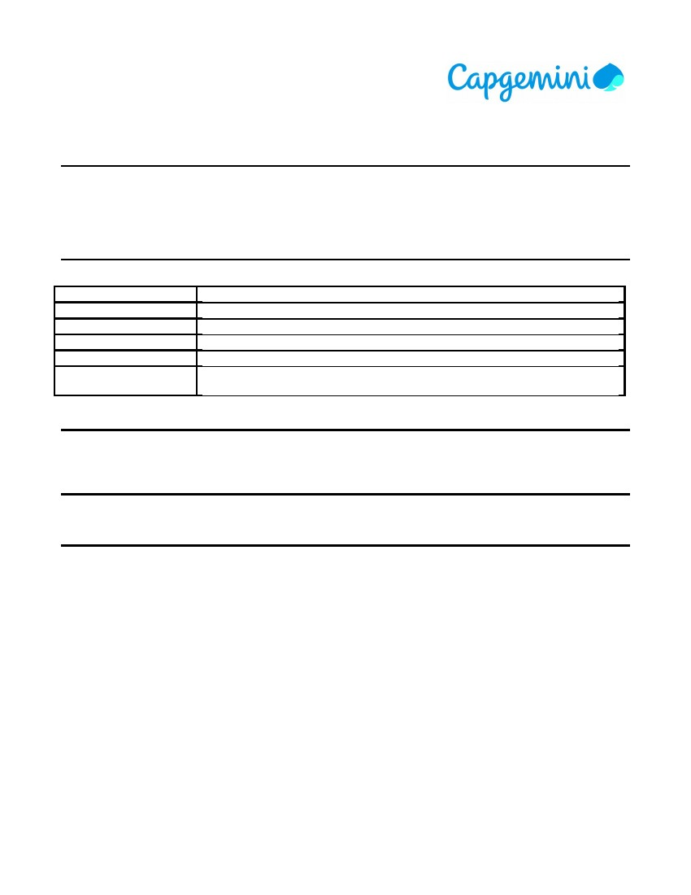

|  |  |
| --- | --- |
| **Career Objective** | |
| To secure a challenging position that utilizes my abilities and skills, while allowing me the opportunity to grow professionally and to excel by contributing to the achievement of organisational goals. | |
| **Skills Profile** | |
| Operating System | Windows 7, 8, 10 |
| Environment | Client/Server |
| Database | Oracle |
| Internet Tools | HTML5, Javascript |
| Languages | Core Java, C |
| Others | MS Office |

|  |
| --- |
| **Professional Organizations** |
| Capgemini India, Senior Analyst Sep'18 - Current  Tata Steel Pvt. Ltd., Intern May'17-Jun'17   * Title of project was Process visualization and Diagnostic Model Development using Data techniques. * Developed a web application with R language. |

|  |
| --- |
| **Education** |
| B.Tech(Hons.),Electronics and Communication Engineering 2018  National Institute of Technology, Jamshedpur CGPA-8.72 |